Grafice Tema 2

**Straturi Fully Connected**

* CIFAR

Arhitectura: Linearize, FullyConnected(300), TanH, FullyConnected(10), SoftMax

Learning rate: 0.001

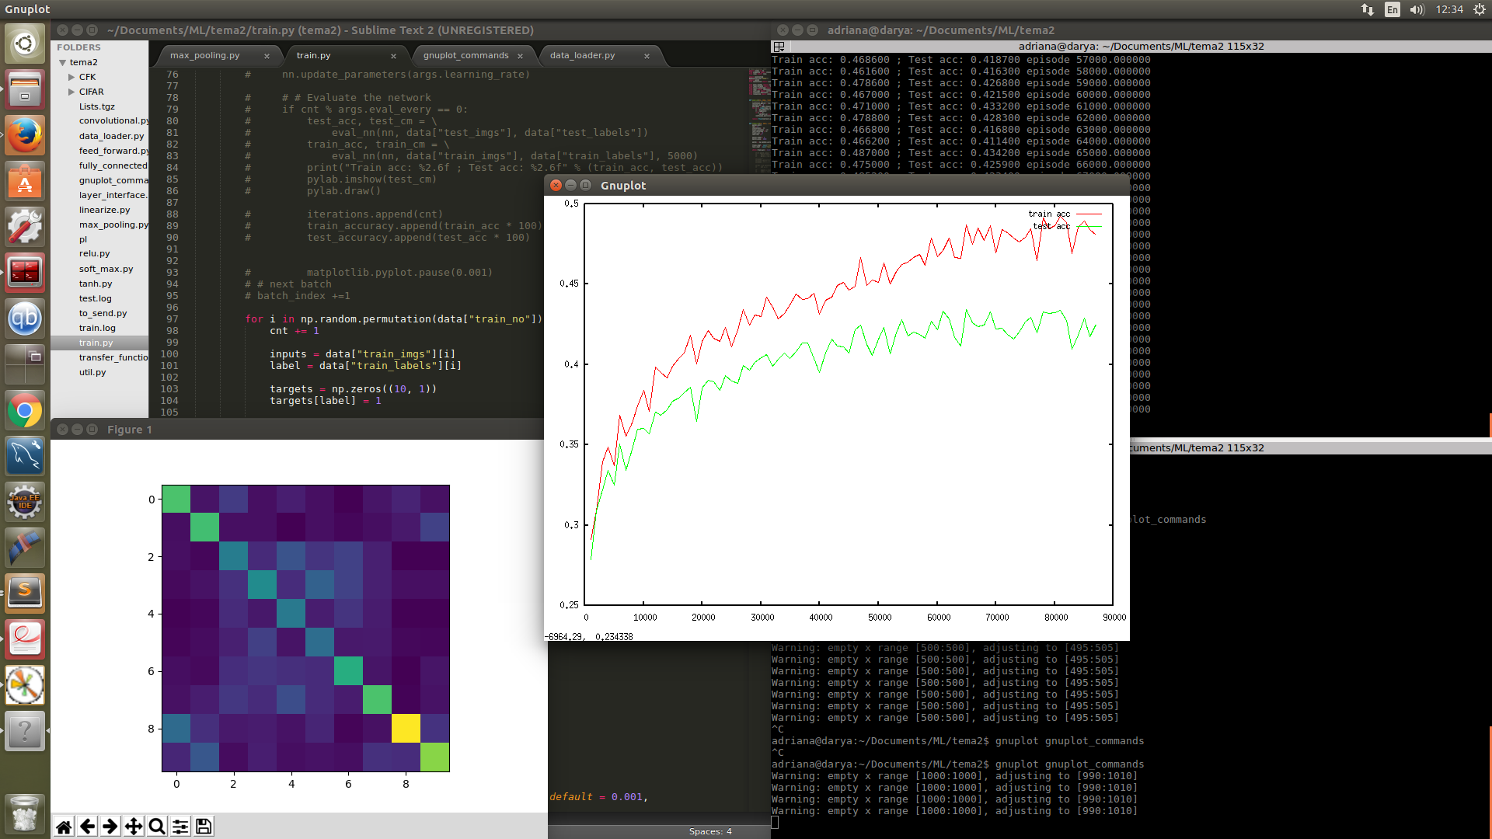

* CIFAR (numar de straturi schimbat)

Arhitectura: Linearize, FullyConnected(600), TanH, FullyConnected(400), TanH, FullyConnected(100), TanH, FullyConnected(10),SoftMax

Learning rate: 0.001

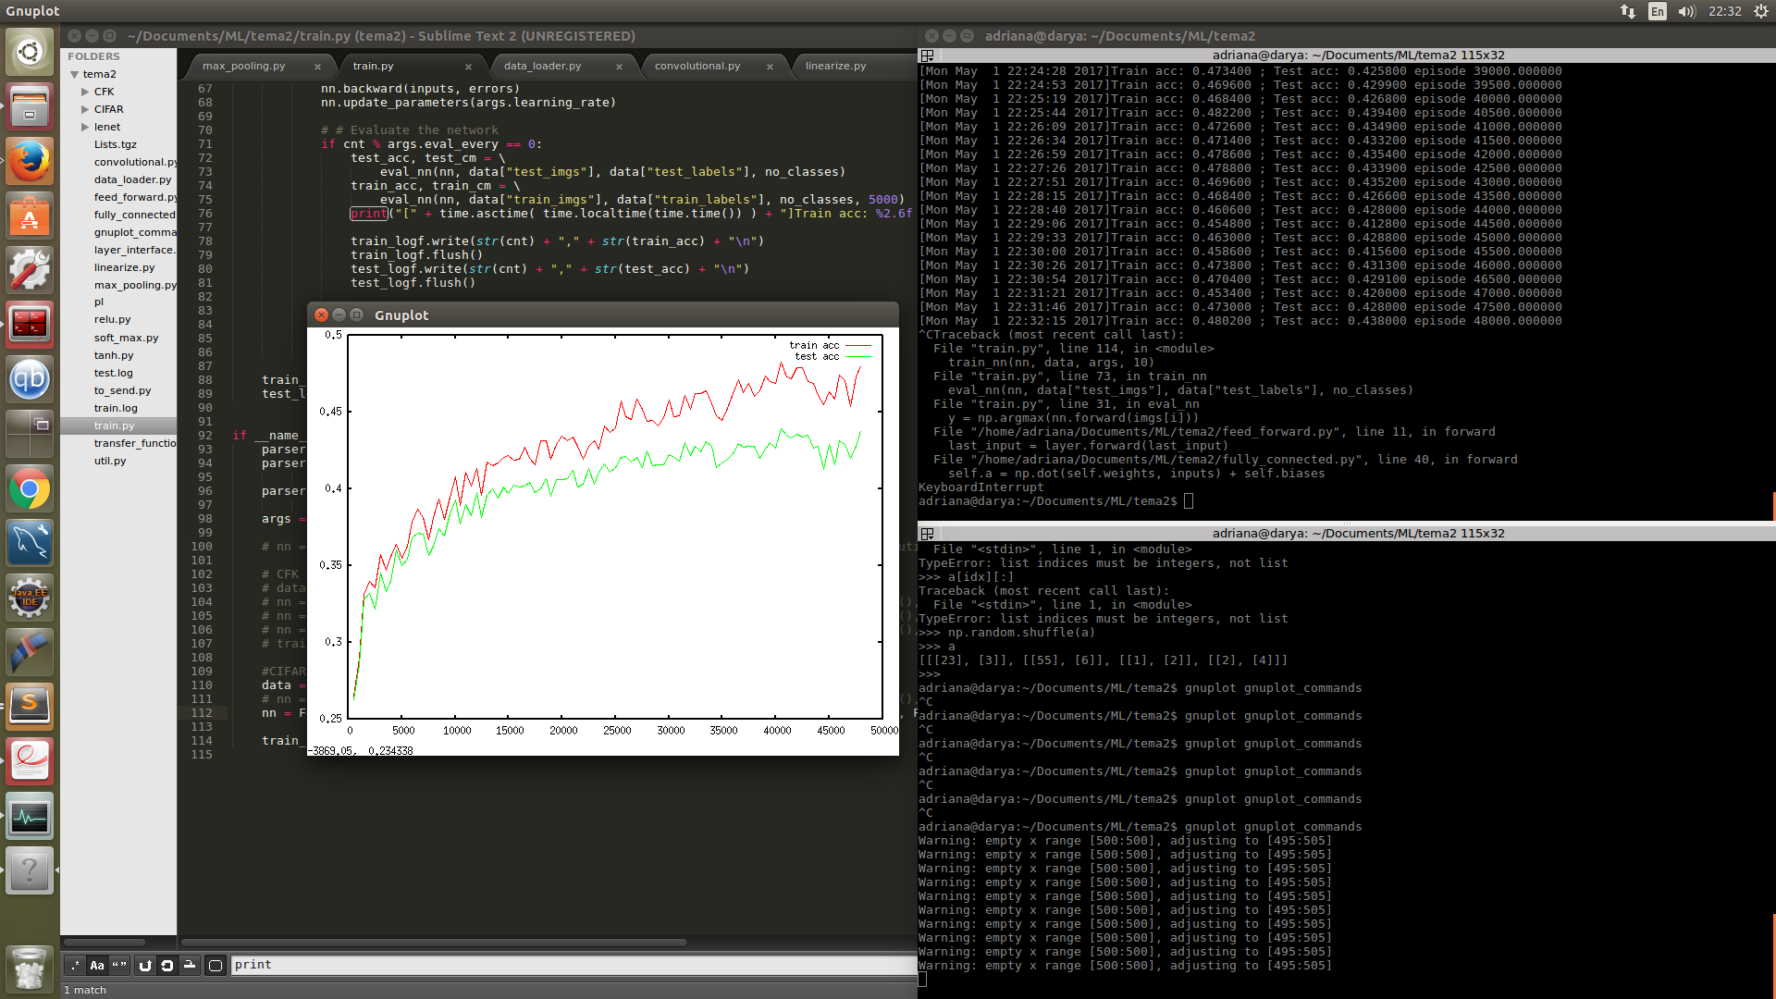

* CFK

Arhitectura: Linearize, FullyConnected(300), TanH, FullyConnected(62), SoftMax

Learning rate: 0.001

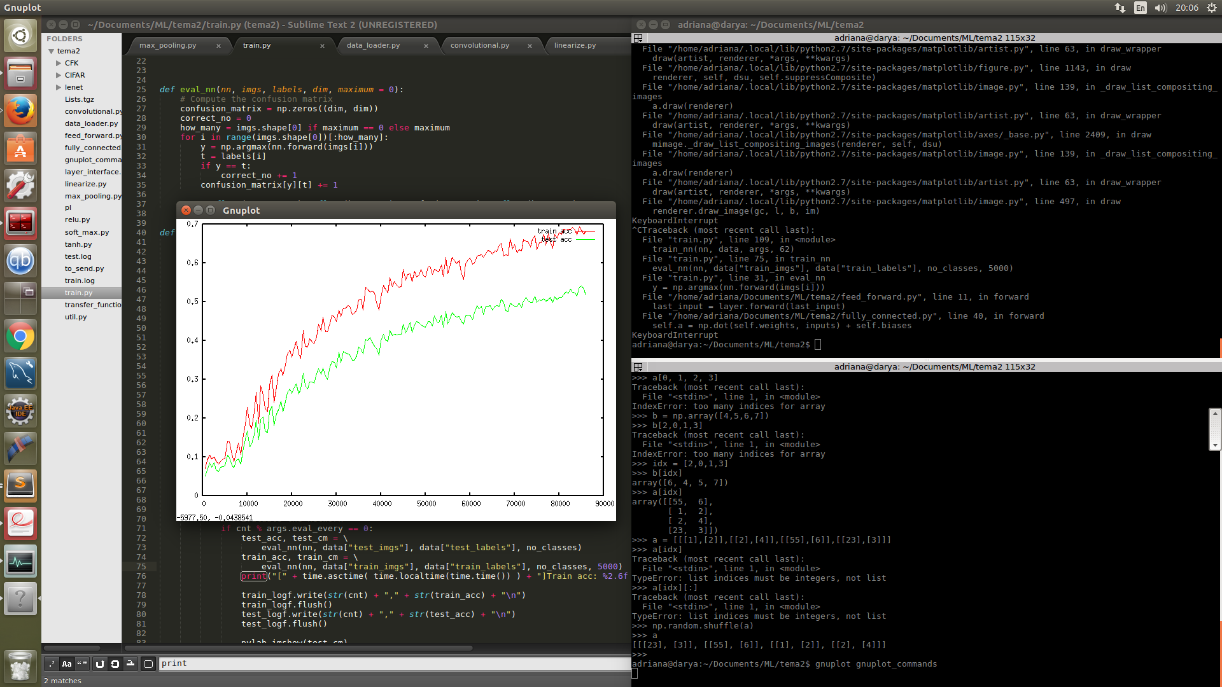

Momentum: 0.6 (pentru 0.9 avansa prea incet)

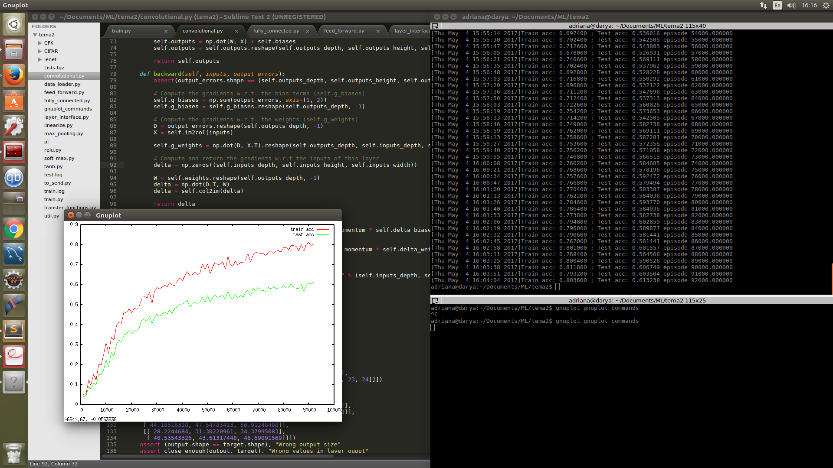

* CFK (learning rate schimbat)

Arhitectura: Linearize, FullyConnected(300), TanH, FullyConnected(62), SoftMax

Learning rate: 0.01

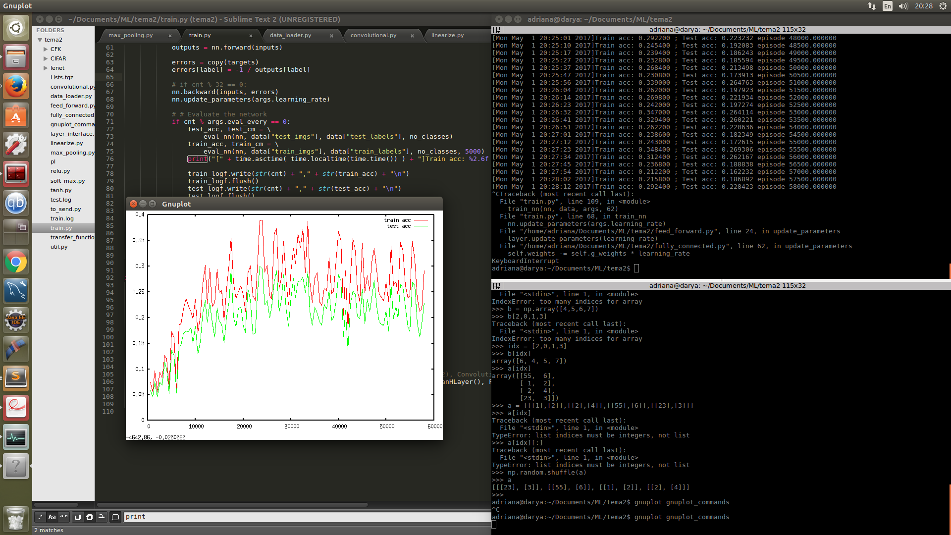

* CFK (learning rate schimbat)

Arhitectura: Linearize, FullyConnected(300), TanH, FullyConnected(62), SoftMax

Learning rate: 0.0001

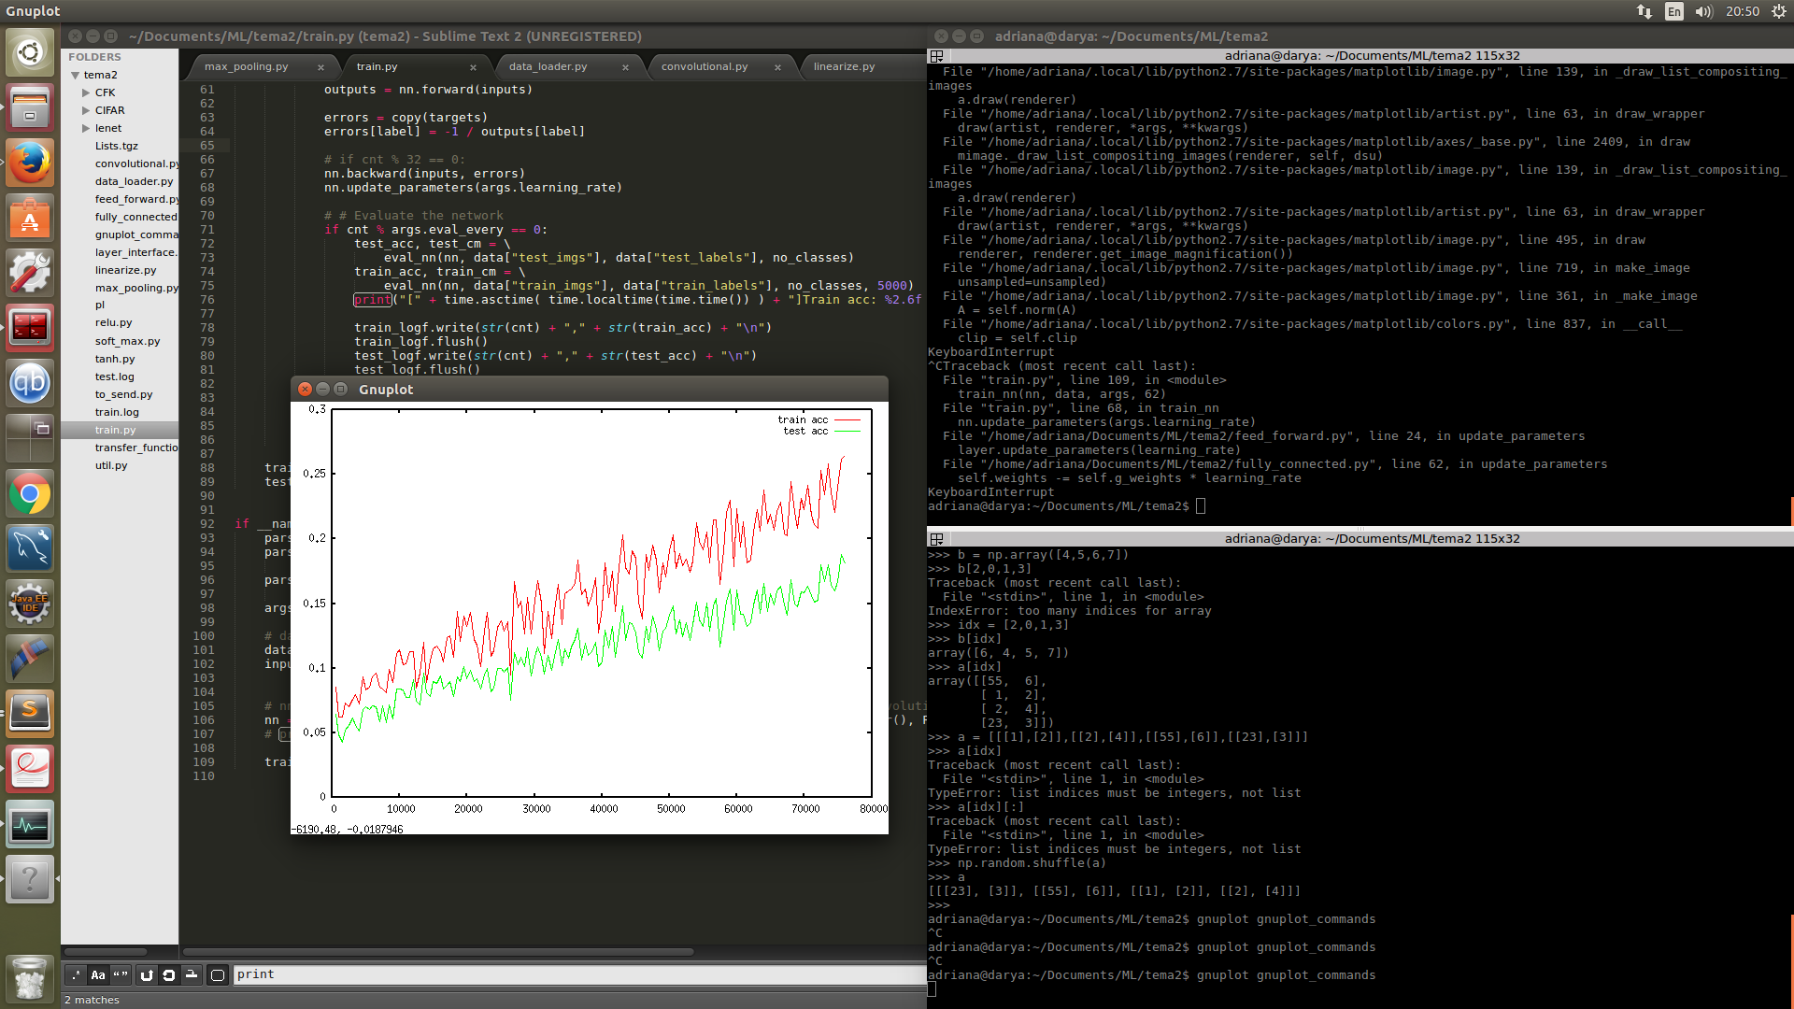

* CFK (numar de straturi schimbat)

Arhitectura: Linearize, FullyConnected(300), TanH, FullyConnected(100), TanH, FullyConnected(62), SoftMax

Learning rate: 0.001

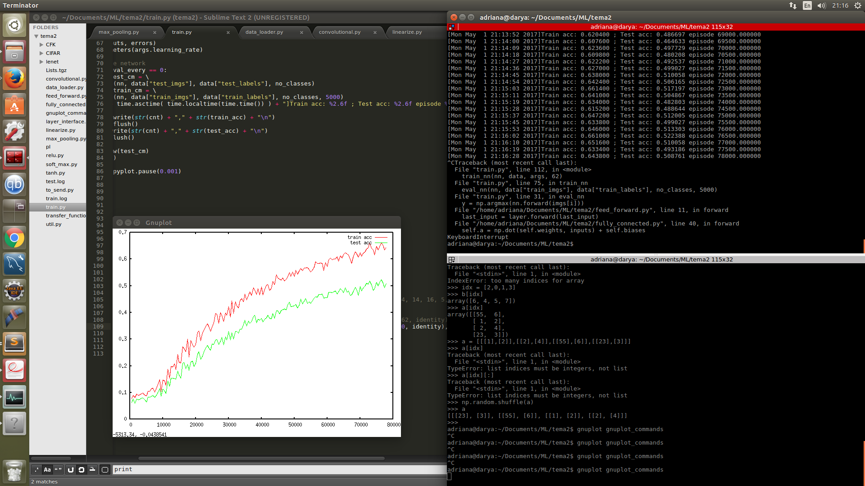

Momentum: 0.6

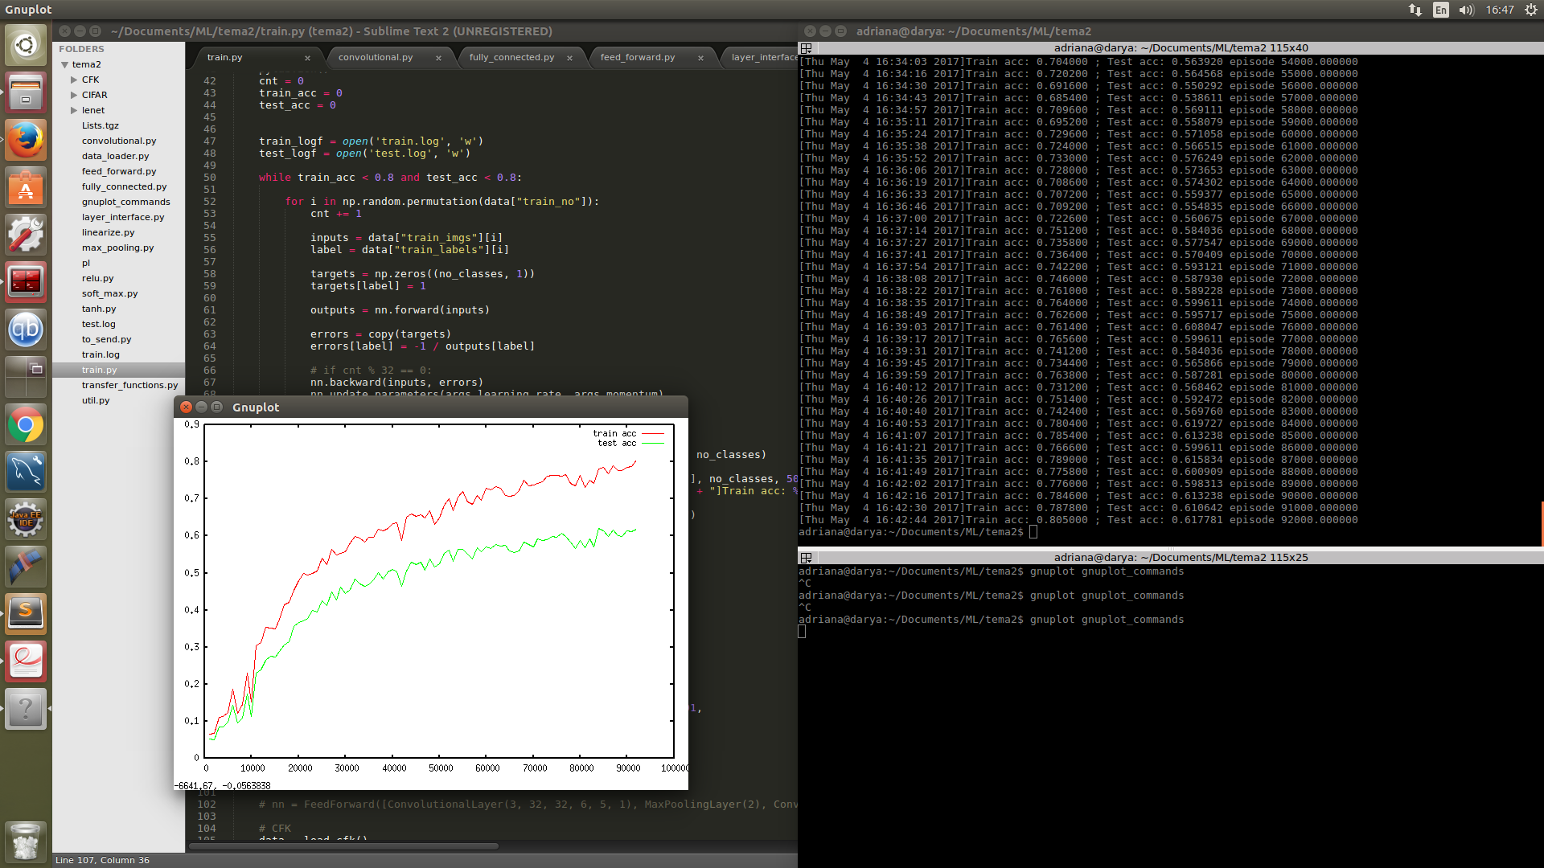

* CFK (numar de neuroni schimbat)

Arhitectura: Linearize, FullyConnected(600), TanH, FullyConnected(62), SoftMax

Learning rate: 0.001

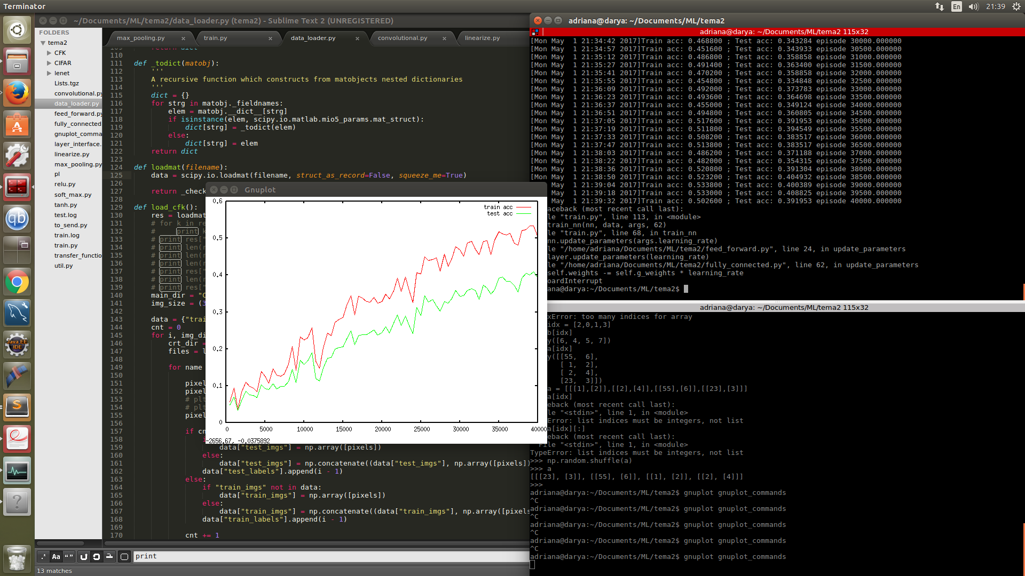

Momentum: 0.6

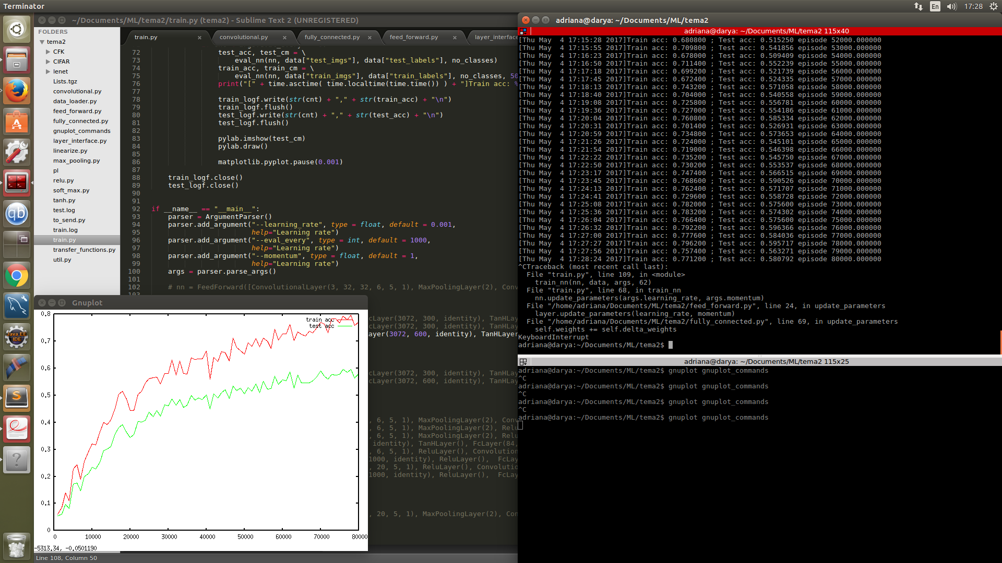

**Straturi de convolutie**

* CIFAR

Arhitectura: Conv(6x5x5), MaxPooling, Conv(16x5x5), MaxPooling, Conv(120x5x5), Linearize, FullyConnected(84), FullyConnected(10), SoftMax

LearningRate: 0.001

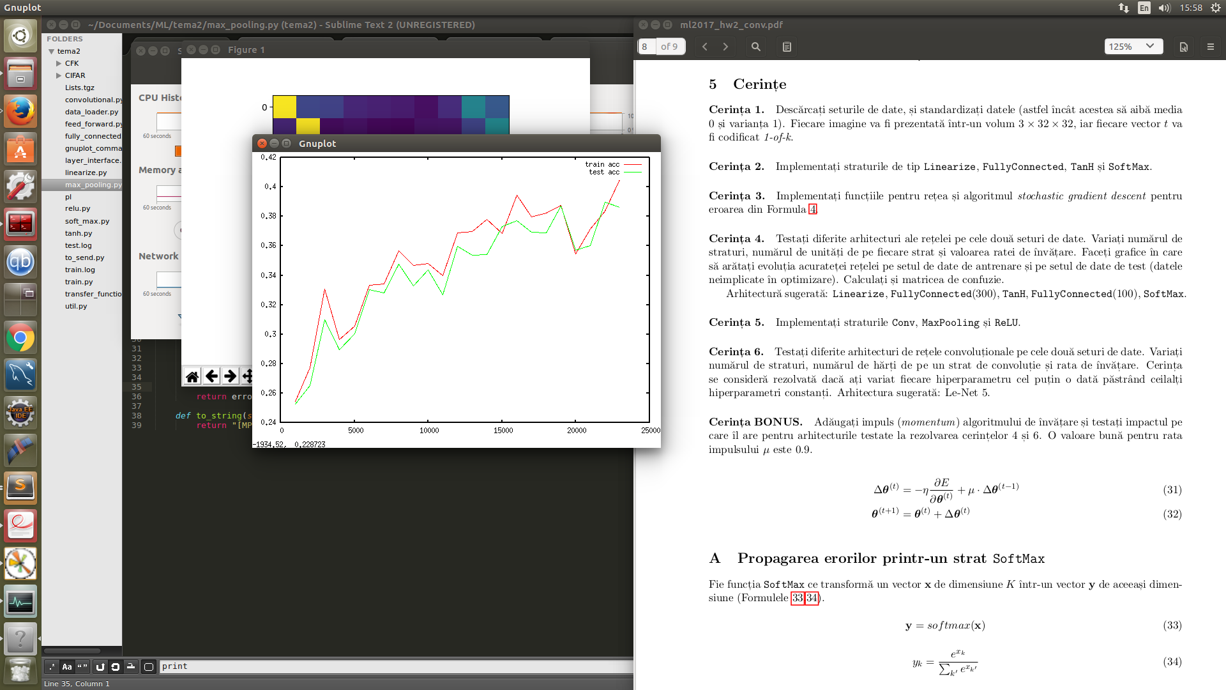

* CIFAR (nr de filtre schimbat)

Arhitectura: Conv(20x5x5), MaxPooling, Conv(25x5x5), MaxPooling, Conv(100x5x5), Linearize, FullyConnected(84), FullyConnected(10), SoftMax

Learning rate: 0.001

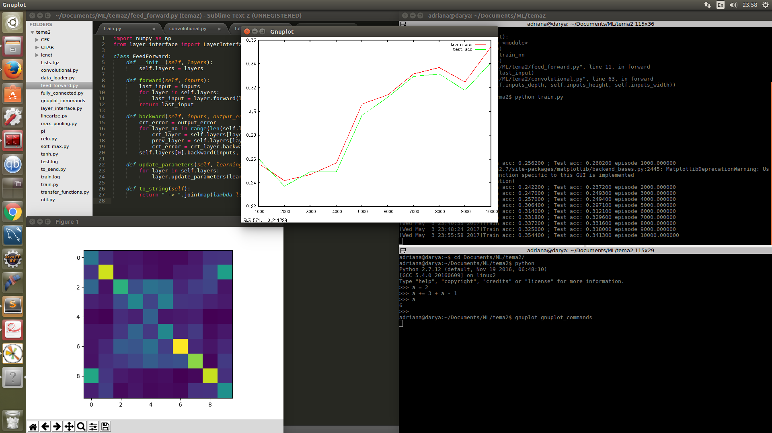

* CFK

Arhitectura: Conv(6x5x5), MaxPooling, Conv(16x5x5), MaxPooling, Conv(120x5x5), Linearize, FullyConnected(84), FullyConnected(62), SoftMax

LearningRate: 0.001

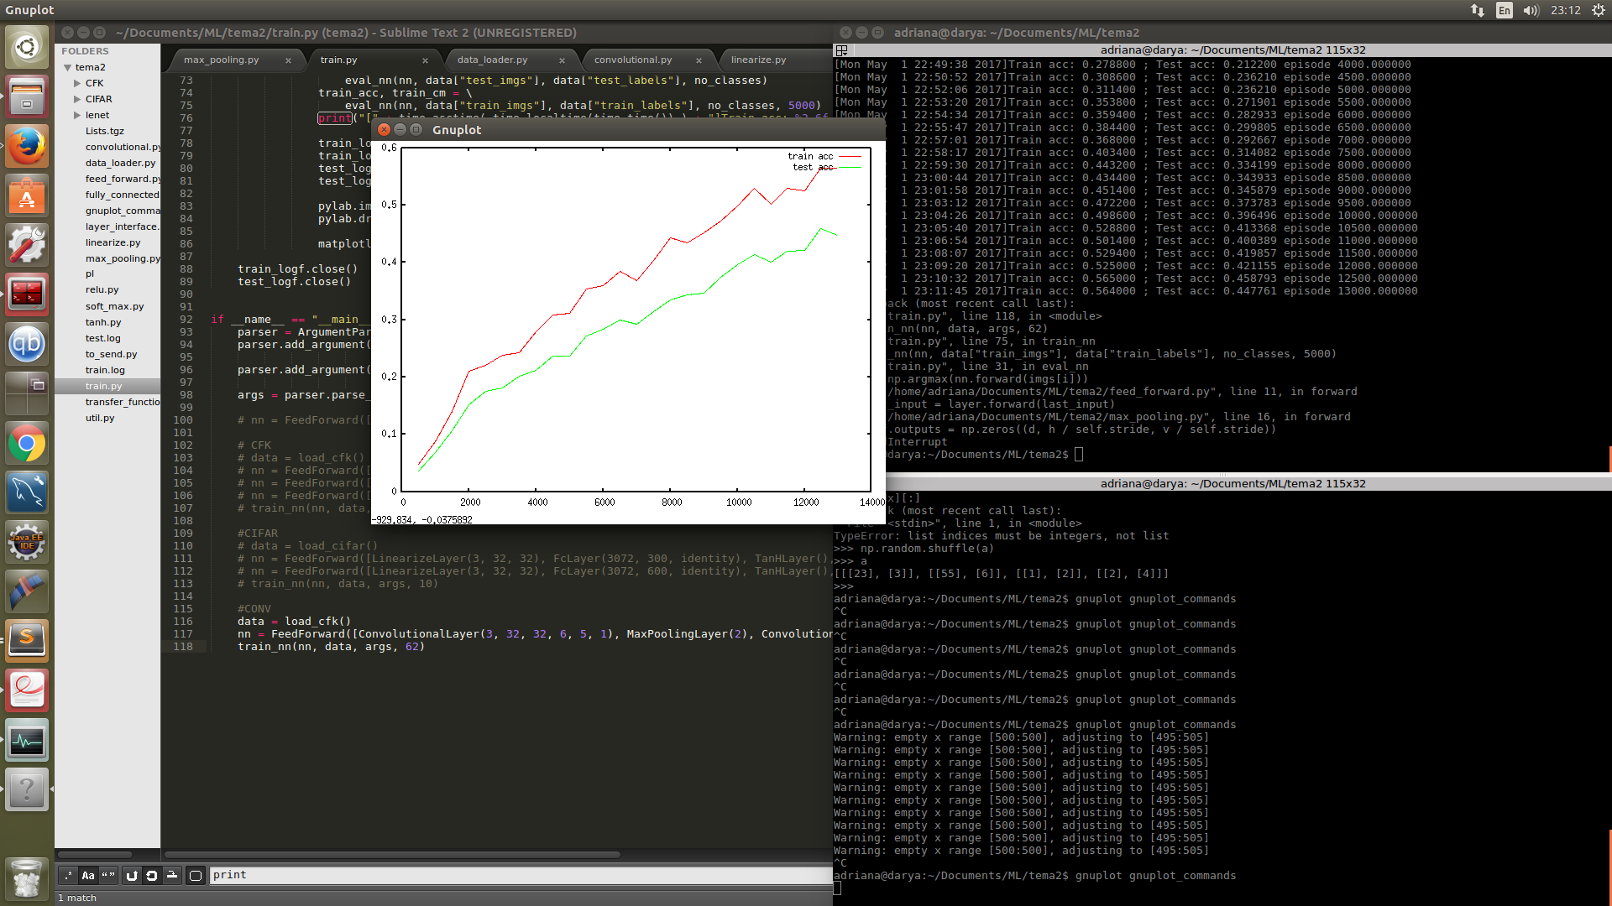

Momentum: 0.6

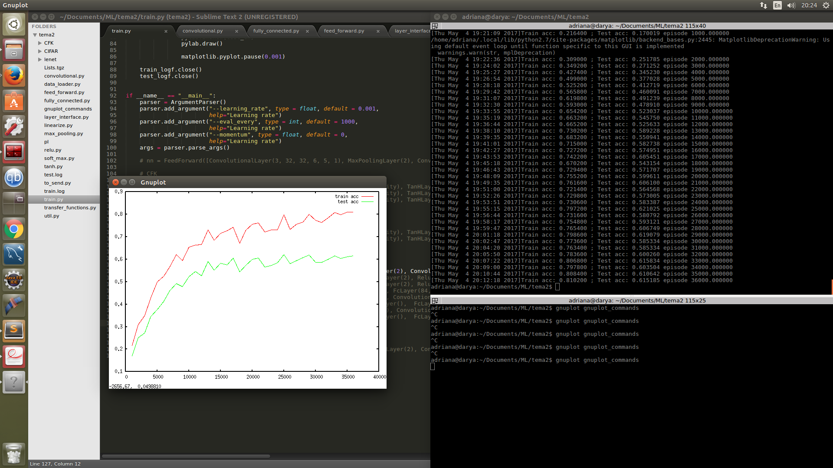

* CFK (learning rate schimbat)

Arhitectura: Conv(6x5x5), MaxPooling, Conv(16x5x5), MaxPooling, Conv(120x5x5), Linearize, FullyConnected(84), FullyConnected(62), SoftMax

LearningRate: 0.01

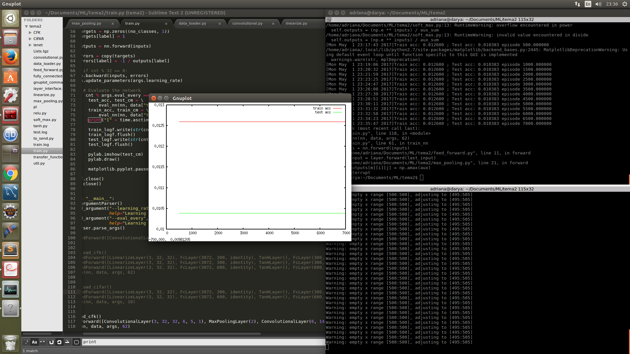

* CFK (learning rate schimbat)

Arhitectura: Conv(6x5x5), MaxPooling, Conv(16x5x5), MaxPooling, Conv(120x5x5), Linearize, FullyConnected(84), FullyConnected(62), SoftMax

LearningRate: 0.0001

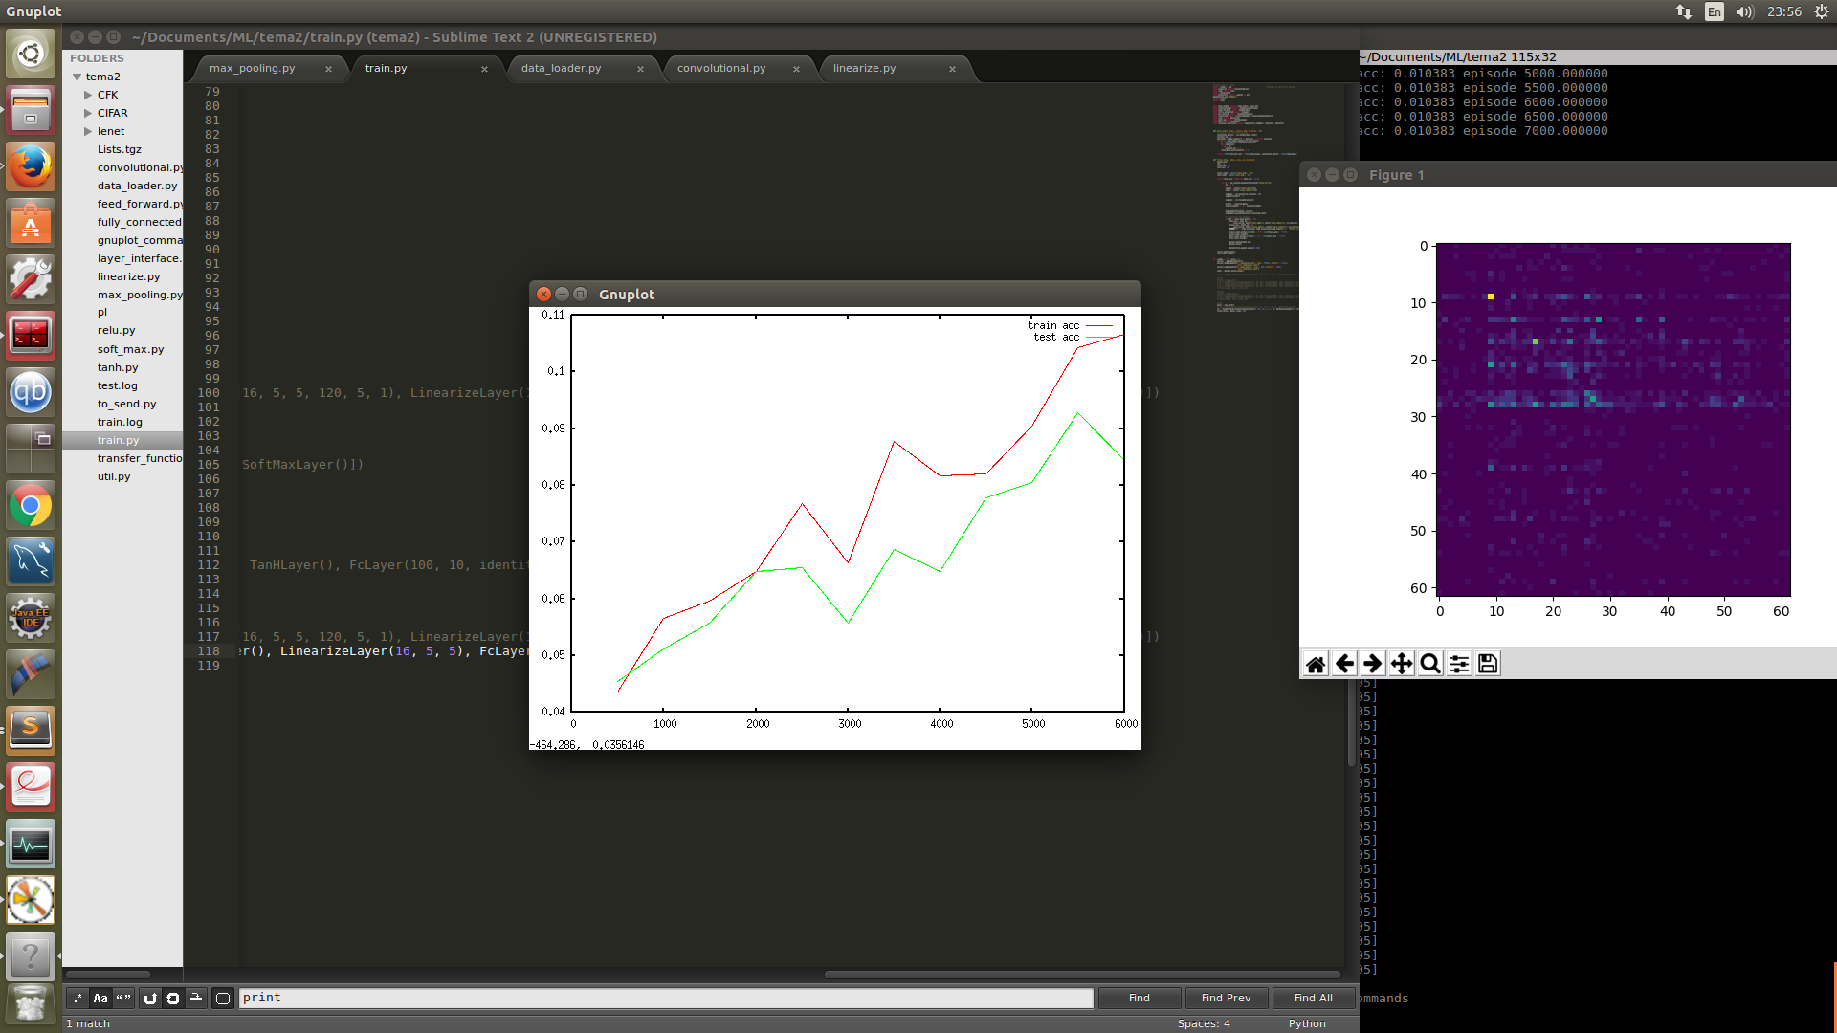

* CFK (arhitectura schimbata)

Arhitectura: Conv(6x5x5), MaxPooling, Relu, Conv(16x5x5), MaxPooling, Relu, Linearize, FullyConnected(300), TanH, FullyConnected(62), SoftMax

LearningRate: 0.001

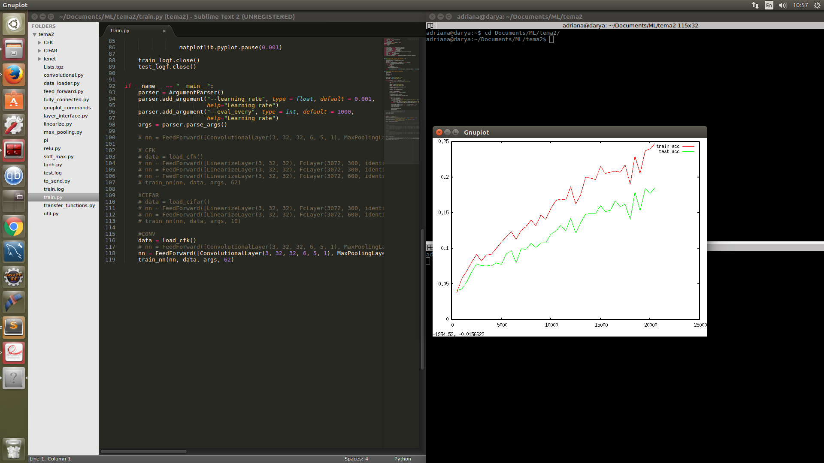

Momentum: 0.6

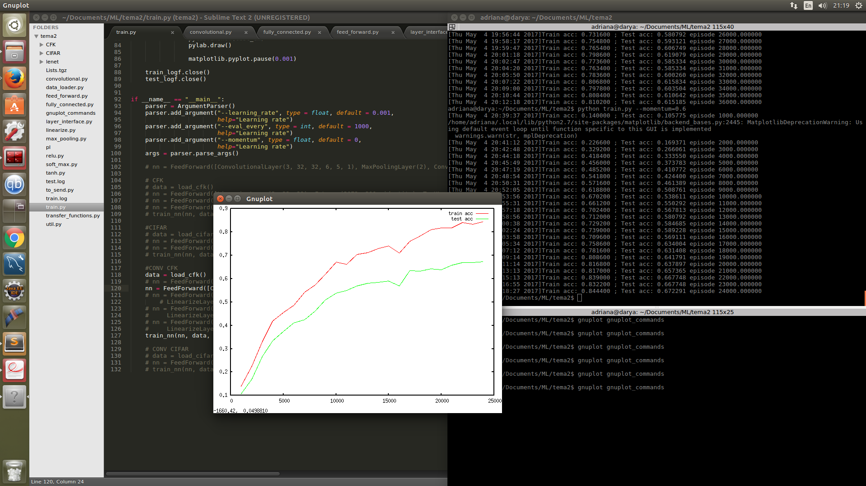

* CFK (nr de straturi schimbat)

Arhitectura: Conv(6x5x5), Relu, Conv(16x5x5), Relu, Conv(25x3x3), Relu, Conv(40x3x3), Relu, MaxPooling, Linearize, FullyConnected(300), Relu, FullyConnected(62), SoftMax

Learning rate: 0.001

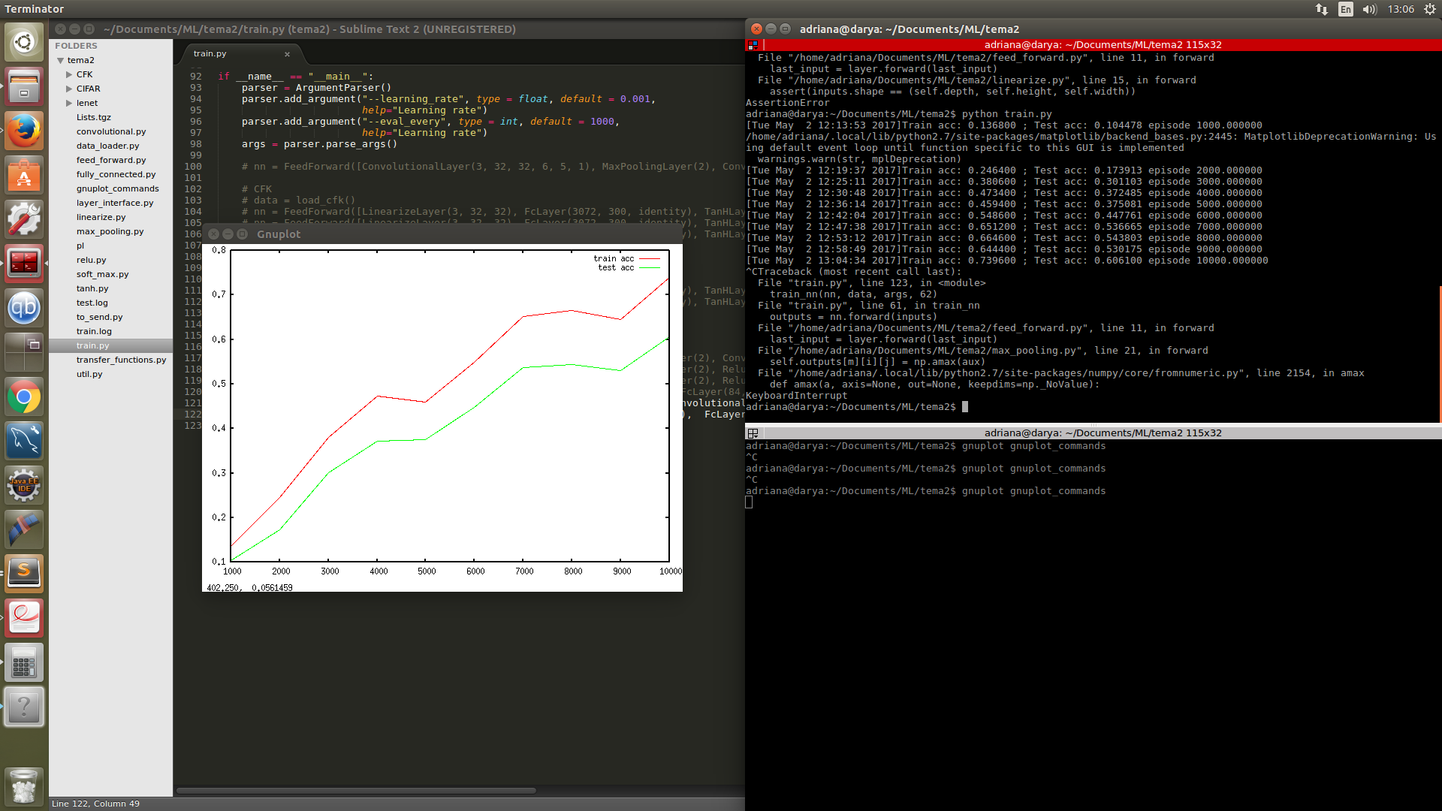

Momentum: 0.6

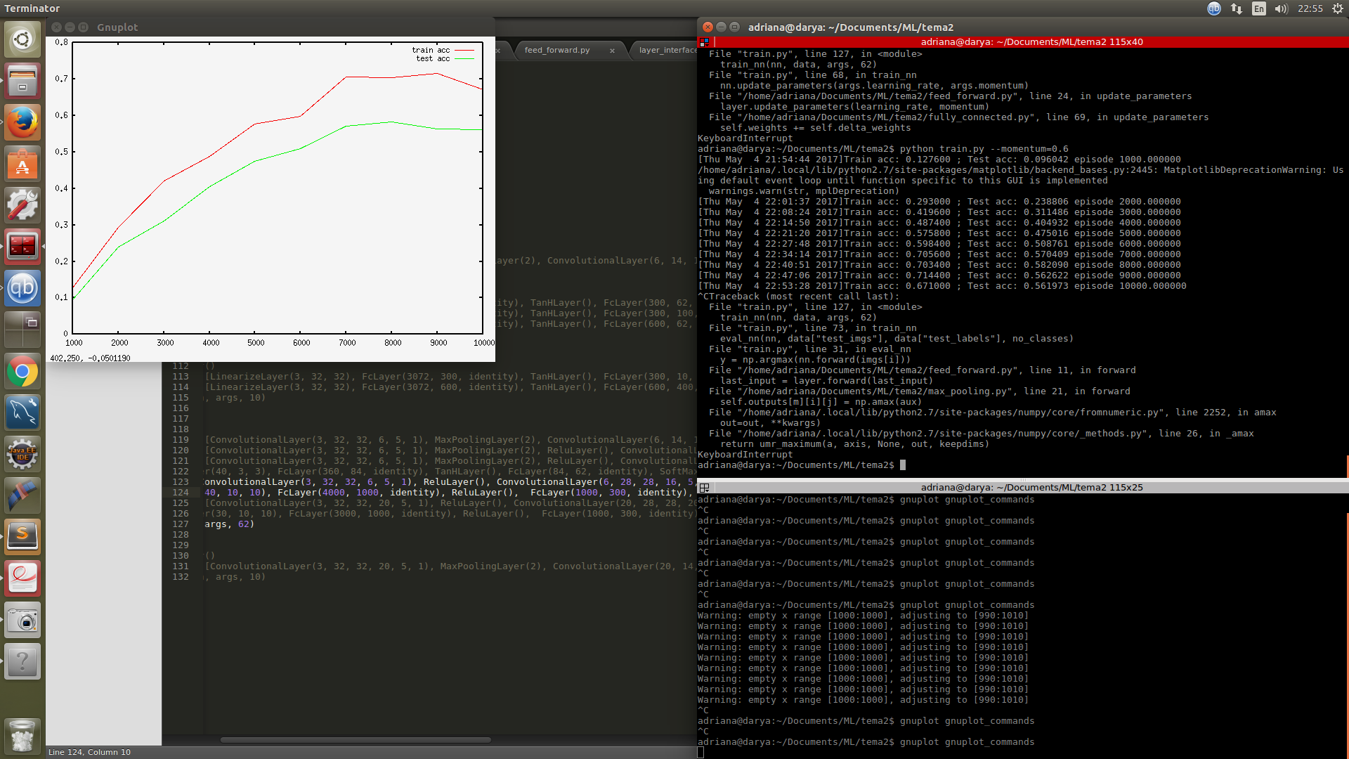

* CFK (numar de filtre schimbat)

Arhitectura: Conv(20x5x5), Relu, Conv(20x5x5), Relu, Conv(50x3x3), Relu, Conv(30x3x3), Relu, MaxPooling, Linearize, FullyConnected(1000), Relu, FullyConnected(300), Relu, FullyConnected(62), SoftMax

Learning rate: 0.001

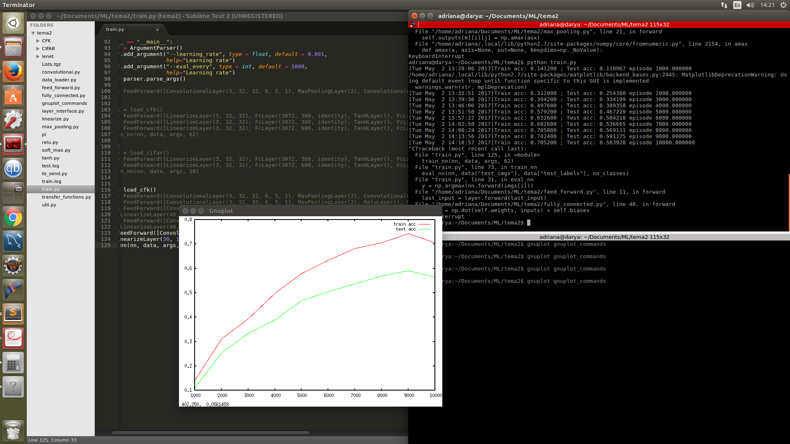

Momentum:0.6

